ACCENTURE PRACTICE TEST – IV

1. If (x+10) % of 240 is 60% more than x% of 180, then 15% of (x+20) is what percent less than 25% of x?

Options:

1. 16 (b) 15 (c)18 (d) 14

Ans: [a]

2. "X XX 7 X XX Y X XX 8 XX”

The 14 – digits of a credit card are to be written in the boxes are shown above. If the sum of every three consecutive digits is 18, then the value of Y is:

Options:

1. 3 (b)4 (c)2 (d)1

Ans: [a]

3. The question given below is followed by 3 – statements. Determine if the statements are, individually or together, sufficient to answer the question

Question

What is the principal?

Statements

(a) The SI received in 2 years at 8% per annum on principal is Rs.450 less than the CI received in (b) Years at the rate of 8% per annum on the same principal.

(c) The principal becomes double at the rate of SI at 6% per annum in 10 years.

(d) The CI compounded annually on the principal at 8% per annum in 2 years is Rs.4540

Ans: [Only a & c]

4. The question given below is followed by 2 – statements. Determine if the statements are, individually or together, sufficient to answer the question.

Question:

If a student is selected at random from school X, then what is the probability that the student is a boy?

Statements

(a) If 20 boys are dropped from the school, then the probability of selecting one boy will be 4/7.

(b) The number of boys is 40 more than the number of girls

Ans: [ Both a and b]

5. Study the following information and answer the questions that follow:

(a) Six friends A, B, C, D, E and F are sitting along the sides of a hexagonal table for playing a game, though not necessarily in the same order.

(b) F, who is sitting exactly opposite A, is to the immediate right of B.

(c) D is between A and B and is exactly opposite to C.

Three of the following are alike in a certain way on the basis of sitting positions and so form a group. Which is the one that does not belong to the group?

Ans: [b, c]

6. Four families decided to go for a picnic to Jhum

ansari Talaiya and agreed to meet at a place called Rani ka Talab before moving for the picnic. One family has no kid, while the others have at least one kid each. Amongst each family with kids, at least one kid goes to the picnic. Following is the information about the families.

1) The family with two kids came just before the family with no kids.

2) D who does not have any kids reached just before C’s family.

3) P and his wife reached last with their only kid.

4) Q is not B’s husband.

5) Q and S are fathers.

6) C’s and A’s daughters go to the same school.

7) B came before D and met A when she reached the fixed place.

8) R stays farthest from the place and he is a good singer.

9) S explained that his son could not come because of exams.

Whose daughters go to the same school?

Ans: [P & Q]

7. The statements given below are followed by some conclusions. Assume the statements are true, even if they contradict commonly known facts, and determine the conclusion/s that follow/s from the statements logically.

Statements

1. Some bats are rackets.

2. Some rackets are bats.

3. Some bats are balls.

Conclusions

(a) Some balls are bats.

(b) Some balls are not bats.

(c) No racket is ball.

(d) No bat is ball.

Ans: [a & b]

8. The statements given below are followed by some conclusions. Assume the statements are true, even if they contradict commonly known facts, and determine the conclusion/s that follow/s from the statements logically.

Statements:

1. Some sacks are backs.

2. All backs are bones.

3. No bone is muscle.

Conclusions

(a) Some sacks are not muscles.

(b) Some sacks are not bones.

(c) All sacks are bones.

(d) No sack is muscle.

Ans: [a and either b or c follows]

9. The statements given below are followed by some conclusions. Assume the statements are true, even if they contradict commonly known facts, and determine the conclusion/s that follow/s from the statements logically.

Statements

1. Many perfumes are diamonds.

2. All aspirins are powder.

3. No perfume is powder.

Conclusions

(a) Some diamonds are not powders.

(b) Some diamonds are powders.

(c) No aspirins are perfume.

(d) Some diamonds are not aspirins.

Ans: [Only a, c and d follows]

10. In each question below is given a statement followed by two assumptions numbered I and II. Consider the statement and decide which of the given assumption is implicit.

Statement:

Many students were caught red-handed and rusticated while using unfair means during the recent university examinations.

Assumptions

(a) The University authorities have never taken such strong actions earlier.

(b) The examination administration committee had prior knowledge about this issue.

Ans: [If neither a or b is implicit

11. In each question below is given a statement followed by two courses of action numbered I and II. You have to assume everything in the statement to be true. Then decide which of the two suggested courses of action logically follows for pursuing.

Statement

The U.S. and its allies have been claiming that Iran is developing dangerous chemical, biological and nuclear weapons.

Courses of Action

1. The international community should boycott Iran.
2. The U.S. should wage war against Iran just as it did against Iraq a few years ago.

Ans: [ If neither a nor b follows]

12. In a certain code,

A” B implies A + B

A’B implies A – B

A@B implies A Π B

A*B implies A ¥ B

At the Wave cinemas in Sector 18 in Noida, charges for parking are as follows

1. For cycles Rs 2

2. For scooters Rs 5

3. For cars Rs 20

On a particular day there were ‘25’ cycles, ‘40’ scooters and ‘100’ cars parked at the stand, what was the amount collected in that particular day?

Ans: [(25*2)” (40*5)” (100*20)]

14**.** Study the following information carefully to answer these questions.

All the streets of a city are either perpendicular or parallel to one another. The streets are all straight. Streets N, O, P, Q and R are parallel to one another. Streets S, T, U, V, W, X and Y are parallel to one another.

(I) Street N is 1 km east of Street O.

(ii) Street O is 1/2 km west of Street P.

(iii) Street Q is 1 km west of Street R.

(iv) Street S is 1/2 km south of Street T.

(v) Street U is 1 km north of Street V.

(vi) Street W is 1/2 km north of Street X.

(vii) Street W is 1 km south of Street Y.

Which of the following possibilities would make two streets coincide?

Ans: [R is 1/2 km east of O]

15. In the following questions, the symbols +, -, *, / and % are used with the following illustrated

A. X - Y means X is super senior of Y

B. X + Y means X is senior of Y

C. X % Y means X is junior of Y

D. X * Y means X is super junior of Y

E. X / Y means X is same level of Y

Now assuming the information to be true, read the statements and determine the conclusions that most definitely follows

Statements

P + Z, Z / V and V + K

Conclusions

1. Z * P
2. K % Z
3. P – K

Ans: [Only conclusion b & c follow]

16. The question given below is followed by 2 – statements. Determine if the statements are, individually or together, sufficient to answer the question

Question

Is the regular polygon having odd number of sides?

Statements

(a)   Sum of all the angles of the polygon is 1080 degree

(b)   If the measure of each interior angle of the polygon is 140 degrees

Ans: [Statement a and b together are sufficient to answer the question]

17. Which of the following assertions is FALSE about the Internet Protocol (IP)?

(a) It is possible for a computer to have multiple IP addresses

(b) IP packets from the same source to the same destination can take different routes in the network.

(c) IP ensures that a packet is discarded if it is unable to reach its destination within a given number of hops.

(d) The packet source cannot set the route of an outgoing packet; the route is determined only by the routing tables in the routers on the way.

Ans: [d]

18. Which of the following is NOT true with respect to a transparent bridge and a router?

(a) Both bridge and router selectively forward data packets.

(b) A bridge uses IP addresses while a router uses MAC addresses.

(c) A bridge builds up its routing table by inspecting incoming packets.

(d) A router can connect between a LAN and a WAN.

Ans: [b]

19. Which layer is associated with log in/log out from the network?

(a) Transport

(b) Presentation

(c) Data link

(d) Session

Ans: [d]

20. Which layers of the OSI reference model are host to- host layers?

(a) Transport, session, presentation, application

(b) Session, presentation, application

(c) Datalink, transport, presentation, application

(d) Physical, datalink, network, transport

Ans: [a]

21.

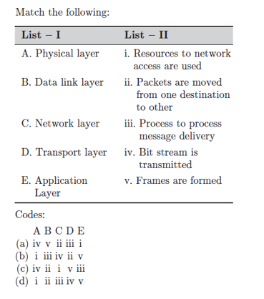

Ans: [a]

22. A hub in the network is

1. a passive device
2. an active device
3. a server that serves every node
4. a power supply concentrator

Ans: [a]

23. Which of the following functionality must be implemented by transport layer over and above the network protocol?

(a) Recovery from packet loss

(b) End to end connectivity

(c) Packet delivery in encapsulated abstract order

(d) Secure transmission from end to end

Ans: [b]

24. Match the following:

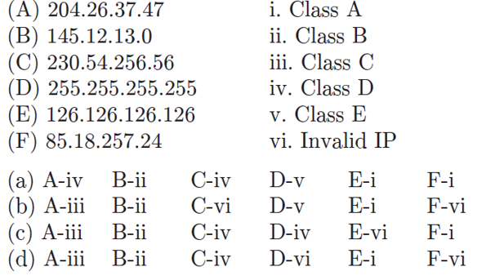

Ans; [a]

25. We need to make a super network out of 16 class C block, what is the super mask?

(a) 255.255.255.240

(b) 255.240.0.0

(c) 255.255.240.0

(d) 255.255.224.0

Ans: [c]

26. MTU stands for

(a) Minimum Transfer Unit

(b) Minimum Telephony Unit

(c) Maximum Transfer Unit

(d) Memory Transfer Unit

Ans: [c]

27. Which protocol is being used in wireless to overcome collision?

(a) CSMA/CD

(b) CSMA/CA

(c) Both

(d) WEP

Ans: [b]

28. What is ransomware?

(a) A nickname for the types of spyware that require a password on boot

(b) Software that steals files from your computer and is used by blackmailers

(c) A software that hijacks your computer and asks you to pay in order for it to be removed

(d) Viruses that infect files and won't let you open them unless you know a certain pass code

Ans: [c]

29. Number of rounds in data Encryption standard algorithm?

(a) 8 rounds

(b) 12 rounds

(c) 16 rounds

(d) 24 rounds

Ans: [c]

30. Which of the following types of network security ensures that potential attacks cannot infiltrate your network?

(a) Firewall

(b) Network Access Control

(c) Virtual Private Network

(d) Both Network Access Control and Virtual Private Network

Ans: [c]

31. The broadcast address for the subnet that IP address 192.168.26.8, 255.255.255.248 is a member of

(a) 192.168.26.225

(b) 192.168.127.255

(c) 192.168.26.255

(d) 192.168.26.0

Ans: [d]